Creating of code documentation

DVTK 2.0

Preconditions

Installation
‘Code Documentation Generator’ is used to generate
- Compiled HTML Help file (.chm)
- Microsoft Help Collection Definition File (.HxC)

Visual Studio .NET Help Integration Kit 2003

NDoc - Code Documentation Generator for .NET
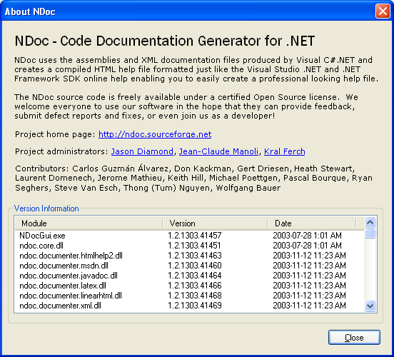

Step by step instructions - DvtkData

Step 1
Run;
DvtkData\DvtkData.ndoc
using;
NDoc - Code Documentation Generator for .NET

Step 2
Documentation->Build
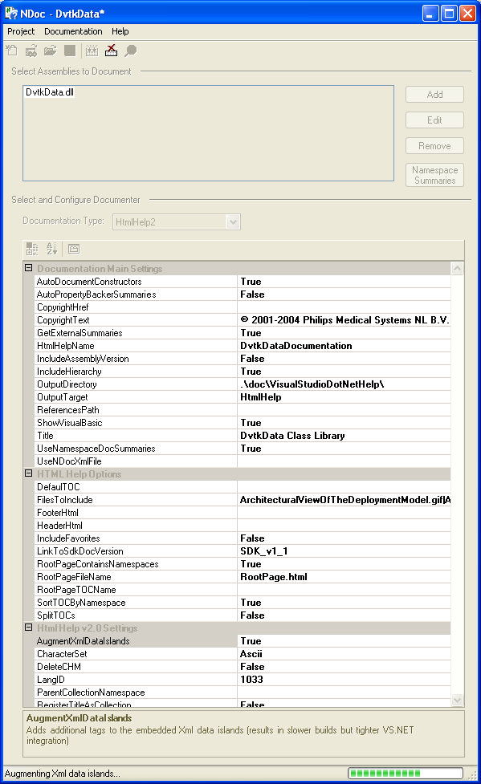
Generates:
- Intermediate HtmlHelp2 files in directory “.\doc\VisualStudioDotNetHelp”
- Compiled HTML Help file (DvtkDataDocumentation.chm)

Step 3
Documentation->View
- This opens a new Visual Studio solution for a ‘Visual Studio .Net Help Project’
DvtkDataDocumentation.HWProj
DvtkDataDocumentation – Help Project
- Manually change the project properties for the new project;
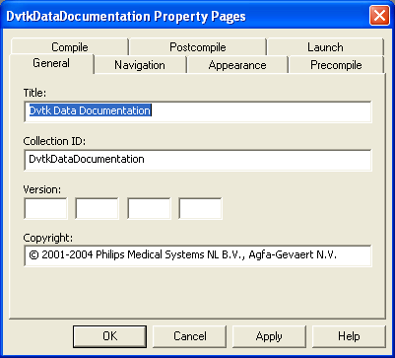
- Build->Solution (save to suggested solution location)
this compiles the help documentation project and generates;
Registered the collection definition file .\doc\VisualStudioDotNetHelp\DvtkDataDocumentation.HxS
- CLOSE THIS SOLUTION!

Step 4
- Start a new visual studio project via ‘File’ -> ‘New’ -> ‘New Project…’
- Select ‘Other Projects’-> ‘Extensibility Projects’ -> ‘Help Integration Wizard (Beta)’ using a project name ‘DvtkDataHelpIntegration’
- Project Settings;
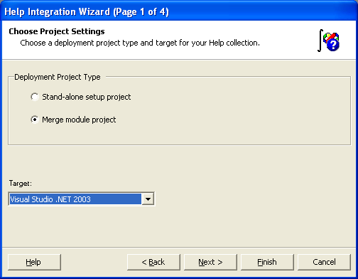
- ‘Next >’
- Select Collection Files – Add… generated HxS
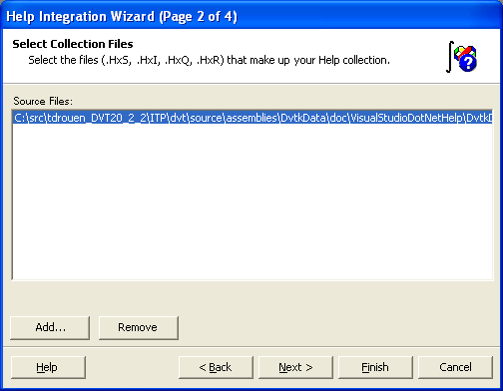
- ‘Next >’
- Build The TOC – ‘<< Include’
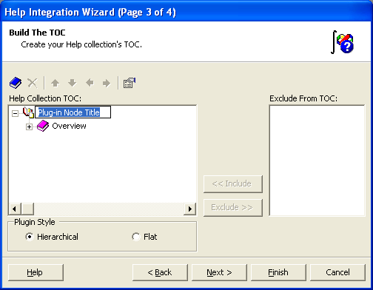
- Change ‘Plug-in Node Title’ to “Dvtk Data Documentation’
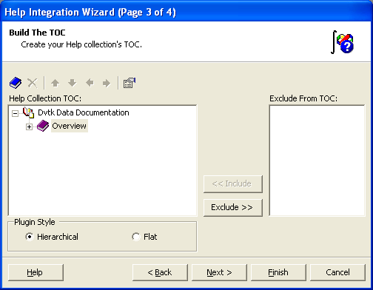
- ‘Next >’
- Set Collection Properties
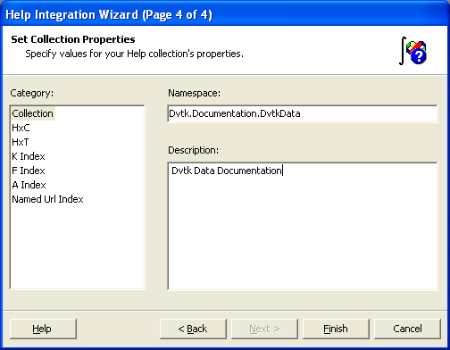
- ‘Finish’
- This generates a DvtkDataHelpIntegration merge-module project
- Change build configuration from ‘Debug’ to ‘Release’
- ‘Build’ to generate ‘DvtkDataHelpIntegration\Release\DvtkDataHelpIntegration.msm’ file.

Step 5
- Copy the ‘DvtkDataHelpIntegration\Release\DvtkDataIntegration.msm’ file to location ‘dvt\distribution\msm’ for input to the installShield.
- Copy the file ‘dvt\source\assemblies\DvtkData\doc\VisualStudioDotNetHelp\DvtkDataDocumentation.chm’ to location ‘dvt\distribution\docs\DvtkDataDocumentation.chm’ for input to the installShield.

Step by step instructions - DVTK

Step 1
Run;
DVTK\DVTK.ndoc
using;
NDoc - Code Documentation Generator for .NET

Step 2
Documentation->Build
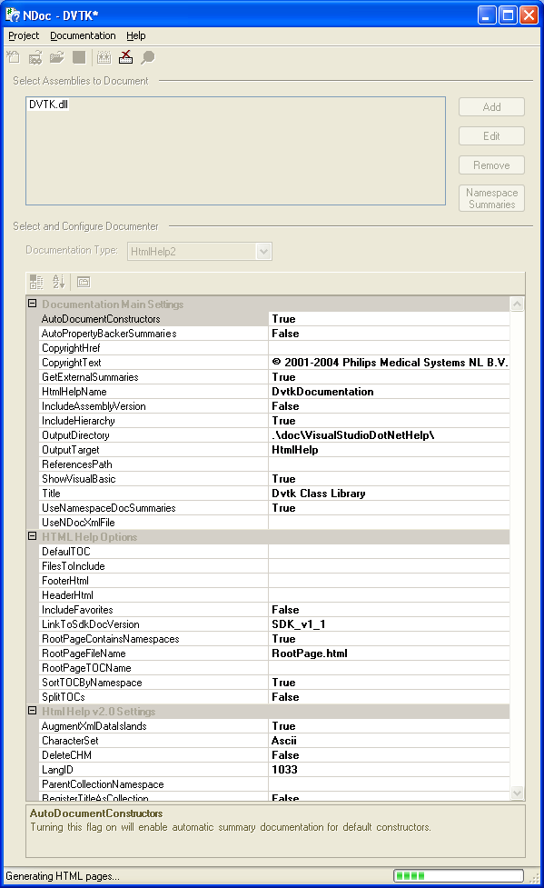
Generates:
- Intermediate HtmlHelp2 files in directory “.\doc\VisualStudioDotNetHelp”
- Compiled HTML Help file (DvtkDocumentation.chm)

Step 3
Documentation->View
- This opens a new Visual Studio solution for a ‘Visual Studio .Net Help Project’
DvtkDocumentation.HWProj
DvtkDocumentation – Help Project
- Manually change the project properties for the new project;
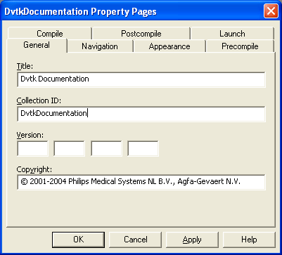
- Build->Solution (save to suggested solution location)
this compiles the help documentation project and generates;
Registered the collection definition file
.\doc\VisualStudioDotNetHelp\DvtkDocumentation.HxS
- CLOSE THIS SOLUTION!

Step 4
- Start a new visual studio project via ‘File’ -> ‘New’ -> ‘New Project…’
- Select ‘Other Projects’-> ‘Extensibility Projects’ -> ‘Help Integration Wizard (Beta)’ using a project name ‘DvtkHelpIntegration’
- Project Settings;
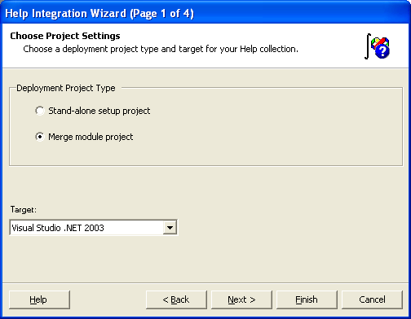
- ‘Next >’
- Select Collection Files – Add… generated HxS
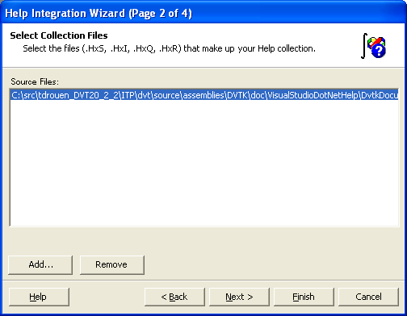
- ‘Next >’
- Build The TOC – ‘<< Include’
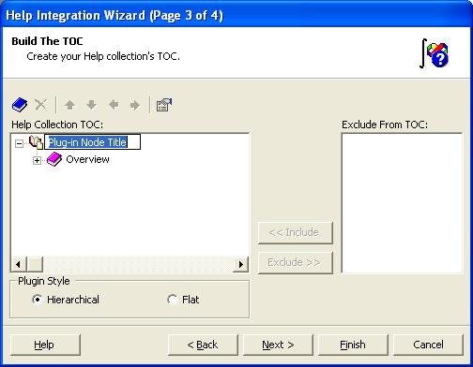
- Change ‘Plug-in Node Title’ to “Dvtk Documentation’
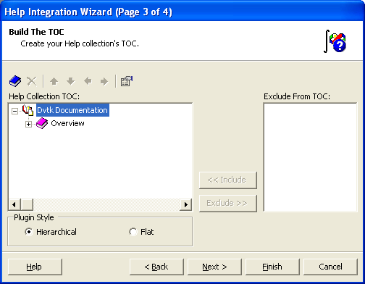
- ‘Next >’
- Set Collection Properties
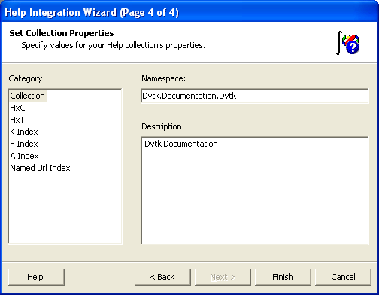
- ‘Finish’
- This generates a DvtkHelpIntegration merge-module project
- Change build configuration from ‘Debug’ to ‘Release’
- ‘Build’ to generate ‘DvtkDataHelpIntegration\Release\DvtkHelpIntegration.msm’ file.

Step 5
- Copy the ‘DvtkHelpIntegration\Release\DvtkIntegration.msm’ file to location ‘dvt\distribution\msm’ for input to the installShield.
- Copy the file ‘dvt\source\assemblies\Dvtk\doc\VisualStudioDotNetHelp\DvtkDocumentation.chm’ to location ‘dvt\distribution\docs\DvtkDocumentation.chm’ for input to the installShield.

The End - Success

